Name: - Om Tripathi

ID NO. :- 21EL008

Division :- 04

Year :- 2023-24

Subject:- Digital System Design (3EL42)

Branch :- Electronics (EL)

Assignment :- 1

# Q-1 :-Write a Verilog code for 2*4 decoder.

Dataflow:-

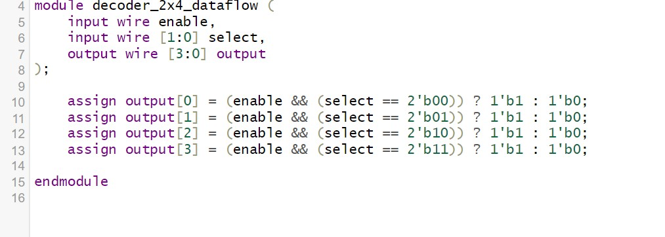

Behavioral:-

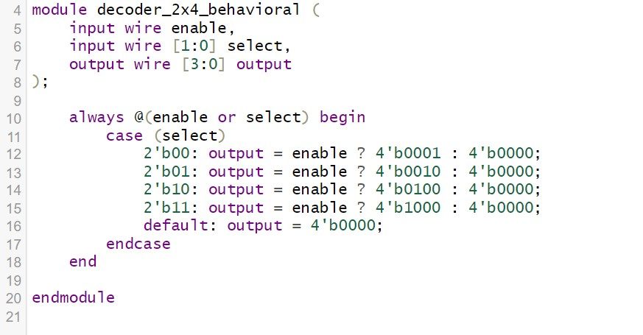

Structural :-

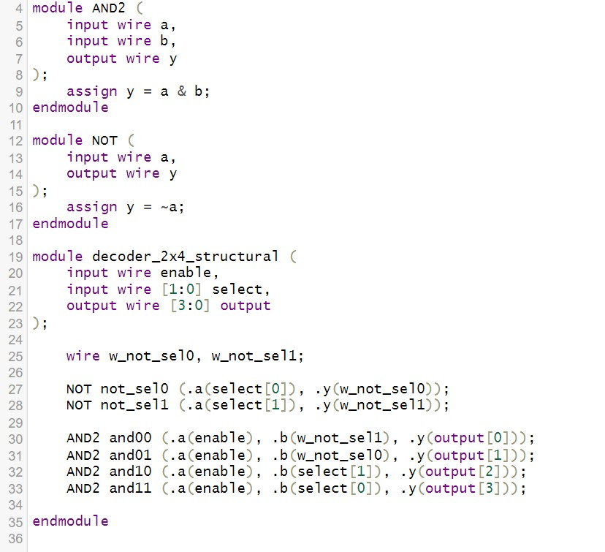

**OUTPUT:-**

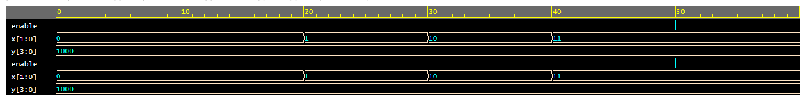

Q-2 :- Write a Verilog code for full subtractor.

Dataflow:-

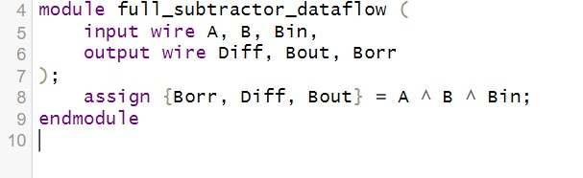

Behavioural :-

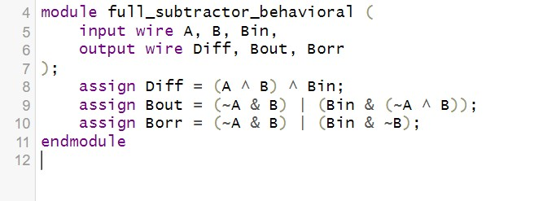

Structural :-

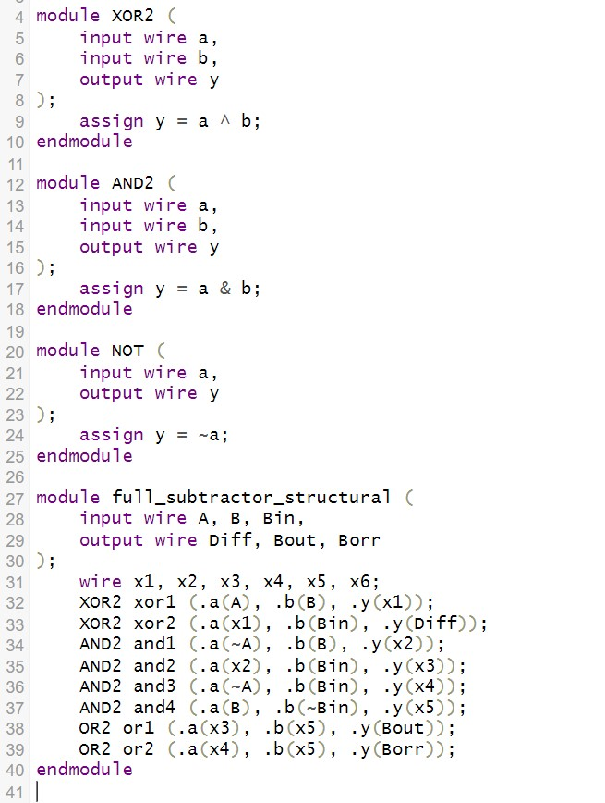

**OUTPUT:-**

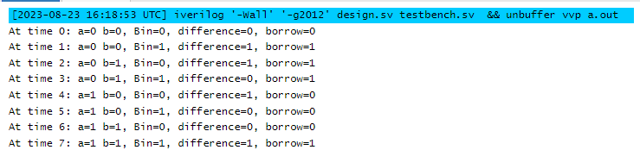

Q-3 :- Write a Verilog code for 2-bit comparator.

Dataflow:-

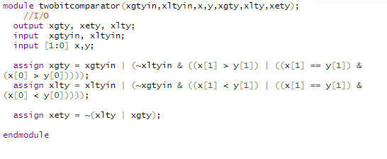

Behavioural :-

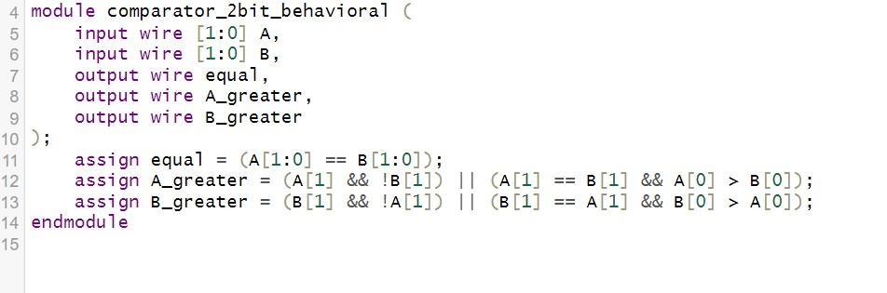

Structural :-

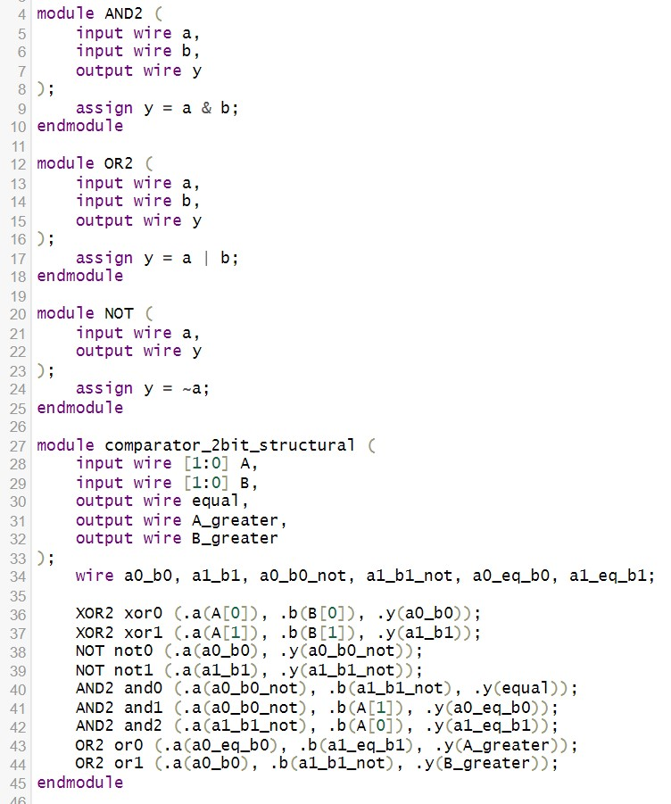

**OUTPUT:-**

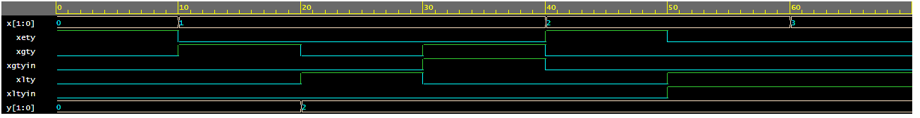

Q-4:- Write a Verilog code for 3 bit binary to gray convertor.

Dataflow:-

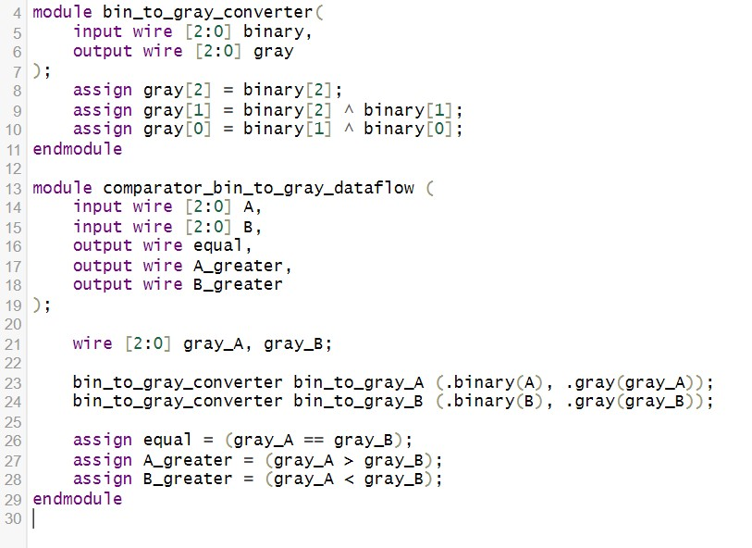

Behavioural :-

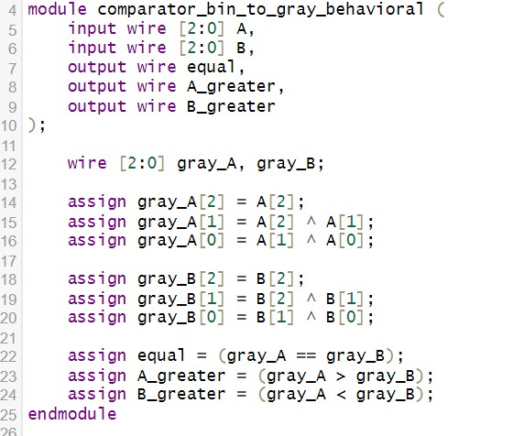

Structural :-

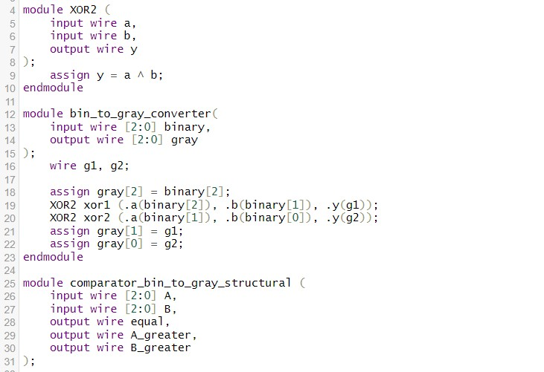

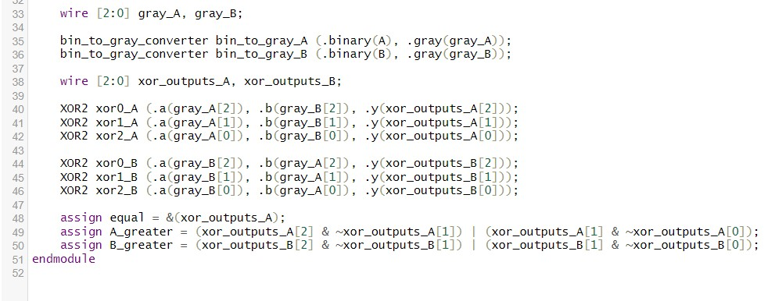

**OUTPUT:-**



Q-5 :- Write a Verilog code for BCD to excess 3 convertors.

Dataflow :-

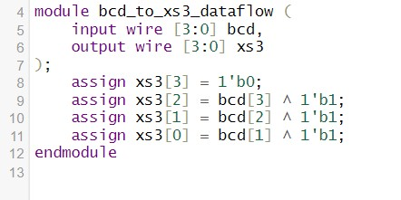

Behavioural :-

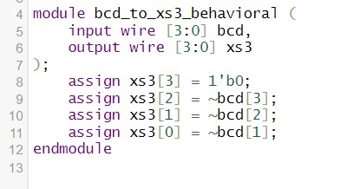

Structural:-

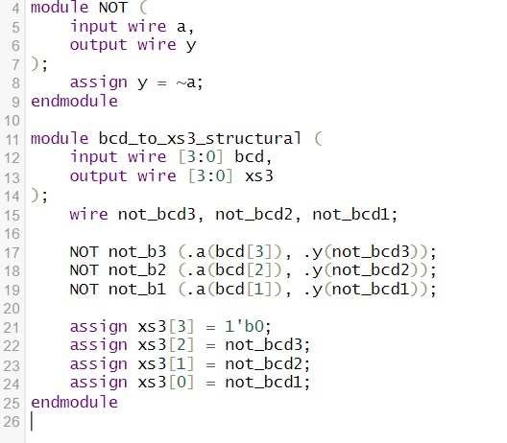

**OUTPUT:-**

